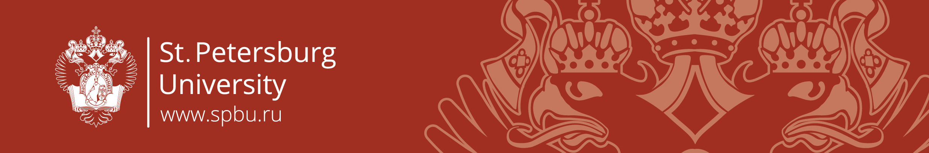

Центр Превосходства Жана Монне
Jean Monnet Centre of Excellence

Studying EU-Russian Relations:
Theories and Methods in Russia and Abroad

Address: Ul. Smolnogo 1/3, entrance 8, room 213

Programme

27 June 2017

9.15 - 9.45 Registration

9.45 - 10.00 Opening

Chair: Konstantin Khudoley, St. Petersburg State University, Professor, European Studies Chair

Irina Nowikowa, St. Petersburg State University, Professor, Dean of the School of International Relations

10.00 - 11.30 Plenary Session “EU-Russian Relations Today: Problems of Methodology”

Chair: Konstantin Khudoley, St. Petersburg State University, Professor, European Studies Chair

Michael Emerson, Centre for European Policy Studies
Alexey Gromyko, Institute of Europe, Russian Academy of Sciences
Richard Sakwa, University of Kent
Tatiana Romanova, St. Petersburg State University

11.30 - 12.00 coffee-break

12.00 - 13.30 – Realism, Geopolitics and Systemic Approach in the Studies of EU-Russian relations

Chair: Alexey Gromyko

Marina Strezhneva, Primakov Institute of World Economy and International Relations, Russian Academy of Sciences,
Ian Klinke, University of Oxford
Alexey Fenenko, Moscow State University
Maciej Raś, University of Warsaw

13.35 - 14.45 lunch (Smolninskaya hotel, ul. Proletarskoi Diktatury 6)

15.00 - 16.30 – Legal Methods, Liberalism and Institutionalism in the Studies of EU-Russian relations

Chair: Michael Emerson

Mark Entin, MGIMO University
Marc Maresceau, Ghent University
Paul Kalinichenko, Kutafin Moscow State Law Academy
Gergana Noutcheva, Maastricht University

16.30 - 16.50 coffee-break

16.50 - 18.20 – Constructivism in the Studies of EU-Russian relations

Chair: Andrey Devyatkov

Paul Flenley, University of Portsmouth
Petr Kratochvíl, Institute of International Relations (Prague)
Natalia Zaslavskaya, St. Petersburg State University
Vasile Rotaru, National University of Political Studies and Public Administration (Bucharest)

18.30 – Departure from the Rastrelli square (in front of the Cathedral)

19.30 – Dinner and a boat tour (by invitation)
the boat will depart from the Admiralteiskaya emb. 16, please be on time

28 June 2017

Parallel sessions:

10.00 - 11.30 – A – Economic Methods in the Studies of EU-Russian relations

Chair: Dmitry Levy

Vasily Astrov, The Vienna Institute for International Economic Studies
Olga Butorina, Institute of Europe, Russian Academy of Sciences
Leonardo Pataccini, Tartu University
Sergei Afontsev, Primakov Institute of World Economy and International Relations, Russian Academy of Sciences

10.00 - 11.30 – B – Normative Power Debates in the Studies of EU-Russian relations

Chair: Richard Sakwa

Florent Parmentier, School of Public Affairs of Sciences Po, Chair of Geopolitics of HEC Paris. Paris
Lyudmila Igumnova, Irkutsk State Univesity
Tom Casier, University of Kent – by Skype
Elena Pavlova, St. Petersburg State University

11.30 - 12.00 coffee-break

12.00-13.30 Europeanisation in the Studies of EU-Russian relations

Chair: Paul Flenley

Tuomas Forsberg, University of Tampere
Dmitry Polyviannyi, Ivanovo State University
Tony van der Togt, Clingendael Netherland Institute of International Relations.
Andrey Devyatkov, Institute of Economics, Russian Academy of Science
Anna Dekalchuk, National Research University – Higher School of Economics

13.35 Closing remarks

